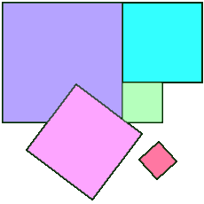
Alison joins together nine squares with side lengths 1, 4, 7, 8, 9, 10, 14, 15 and 18 cm with no gaps and no overlaps, to form a rectangular quilt.
Can you find the dimensions of the finished quilt, and show how Alison fitted the squares together?
Alison wants to make a second quilt from ten squares with side lengths 3, 5, 6, 11, 17, 19, 22, 23, 24 and 25 cm.
Can you find the dimensions of this quilt?

